**UNIT 5**

**ELECTRICAL INSTALLATION**

**Electrical cable types:**

* Coaxial cable – used for radio frequency signals, for example in cable television distribution systems.
* Communications cable
* Direct-buried cable
* Flexible cables
* Heliax cable
* Non-metallic sheathed cable (or nonmetallic building wire, NM, NM-B)
* Metallic sheathed cable (or armored cable, AC, or BX)
* Multicore cable (consist of more than one wire and is covered by cable jacket)
* Paired cable – Composed of two individually insulated conductors that are usually used in DC or low-frequency AC applications
* Portable cord – Flexible cable for AC power in portable applications
* Ribbon cable – Useful when many wires are required. This type of cable can easily flex, and It is designed to handle low-level voltages.
* Shielded cable – Used for sensitive electronic circuits or to provide protection in high-voltage applications.
* Single cable (from time to time this name is used for wire)
* Submersible cable
* Twinax cable
* Twin-lead – This type of cable is a flat two-wire line. It is commonly called a 300 Ω line because the line has an impedance of 300 Ω. It is often used as a transmission line between an antenna and a receiver (e.g., TV and radio). These cables are stranded to lower skin effects.
* Twisted pair – Consists of two interwound insulated wires. It resembles a paired cable, except that the paired wires are twisted

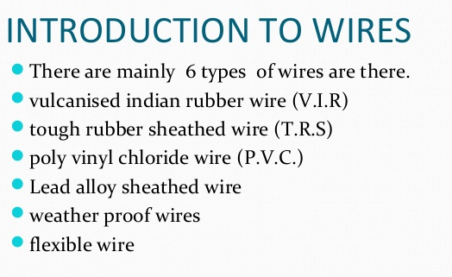

**FUSES:**

A fuse is probably the simplest electrical device, but its function is critical in **protecting electrical circuits from damage**. Fuses are found in every circuit in one form or another in various shapes, sizes, and ratings. In this article, we will learn how a fuse works and about the **different types of the fuse**.

**Characteristics of a Fuse**

There are different types of Fuses available in the market for different types of applications like residential, industrial, automotive, etc. All the fuses are often characterized by the following characteristics.

* Current or Ampere Rating
* Melting Time
* Voltage Rating and
* Interrupting Rating or Breaking capacity
* I2T Value of the Fuse
* Packaging
* Temperature

**FUSE MATERIAL CHARACTERISTICS:**

The material used for fuse elements must be of low **melting point**, low ohmic loss, high **conductivity** (or low **resistivity**), low cost and free from detraction. The material used for making fuse element has a low **melting point** such as tin, lead, or zinc.

**TYPES OF FUSES:**

**1. Renewable fuse:**

## Construction

Renewable fuse consists of a base and a separate fuse element carrier made of porcelain. The base consists of two terminals one for incoming supply and the other for the outgoing supply. Similarly fuse carrier also contains two terminals between which fuse element is connected. Usually one or more strands of fuse wires are used as fuse element. The fuse base and the carrier are designed such that each terminals of base coincides with a terminal of the fuse element. The circuit will be closes only if the fuse carrier is inserted into the base and the fuse element is continuous.

## Working

The working principle of rewirable fuses is very simple. Whenever the current exceeds the predefined value, the flow of current heats the coil and melts it and the fuse is blown out. Thus the circuit is interrupted.

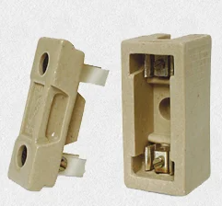

## ****2.HRC Fuse (High Rupturing Capacity Fuse):****

This type of fuse contains a fuse wire in it, which carries the short circuit current safely for a given time period. During this period, if fault is removed, then it does not blow off otherwise it will melt and remove the circuit from electrical supply hence, the circuit remains safe.

The common material, which is used to make an HRC fuse is glass, but this is not always the case. Other chemical compounds are also used in HRC fuse manufacturing and construction based on different factors. Its external enclosure is made fully airtight in order to avoid the effect of atmosphere on the fuse materials. The major objection on HRC fuse is low and uncertain breaking capacity of semi-enclosed fuse.

**Construction and Operations of HRC fuse:**

HRC Fuse consists of highly heat resistant material (such as ceramic) body having metal-end caps, which is welded by silver current carrying element. The fuse body internal space is completely packed with a filling powder. The material, which has filled the insider space, may be plaster of Paris, quartz, chalk, marble, dust and cooling mediums etc. That’s why it carries normal current without overheating. The heat being produced vaporizes the silver melted element. Chemical reaction taking place between silver vapor and filling powder results in high resistance substance, which helps in quenching the arc in fuse.

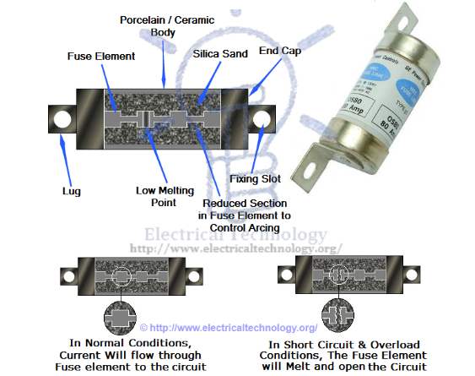

**EARTHING:**

To connect the metallic (conductive) Parts of an Electric appliance or installations to the earth (ground) is called **Earthing**or **Grounding**.

### ****Methods and Types of Electrical Earthing****

Earthing can be done in many ways. The various methods employed in earthing (in house wiring or factory and other connected electrical equipment and machines) are discussed as follows.

#### ****Plate Earthing:****

In plate earthing system, a plate made up of either copper with dimensions **60cm x 60cm x 3.18mm** (i.e. **2ft x 2ft x 1/8 in**) or galvanized iron (GI) of dimensions 60cm x 60cm x 6.35 mm (2ft x 2ft x ¼ in) is buried vertical in the earth (earth pit) which should not be less than 3m (10ft) from the ground level.

For proper earthing system, follow the above mentioned steps in the (Earth Plate introduction) to maintain the moisture condition around the earth electrode or earth plate.

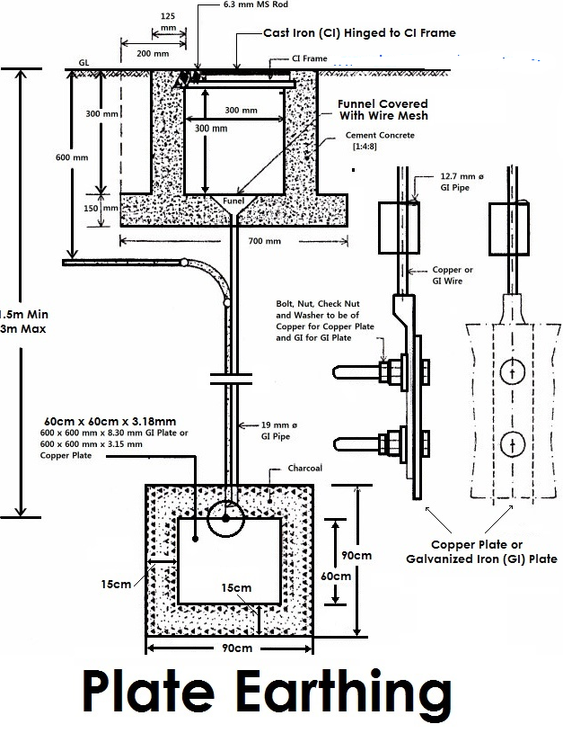

#### ****Pipe Earthing:****

A galvanized steel and a perforated pipe of approved length and diameter is placed vertically in a wet soil in this kind of system of earthing. It is the most common system of earthing.

The size of pipe to use depends on the magnitude of current and the type of soil. The dimension of the pipe is usually 40mm (1.5in) in diameter and 2.75m (9ft) in length for ordinary soil or greater for dry and rocky soil. The moisture of the soil will determine the length of the pipe to be buried but usually it should be 4.75m (15.5ft).

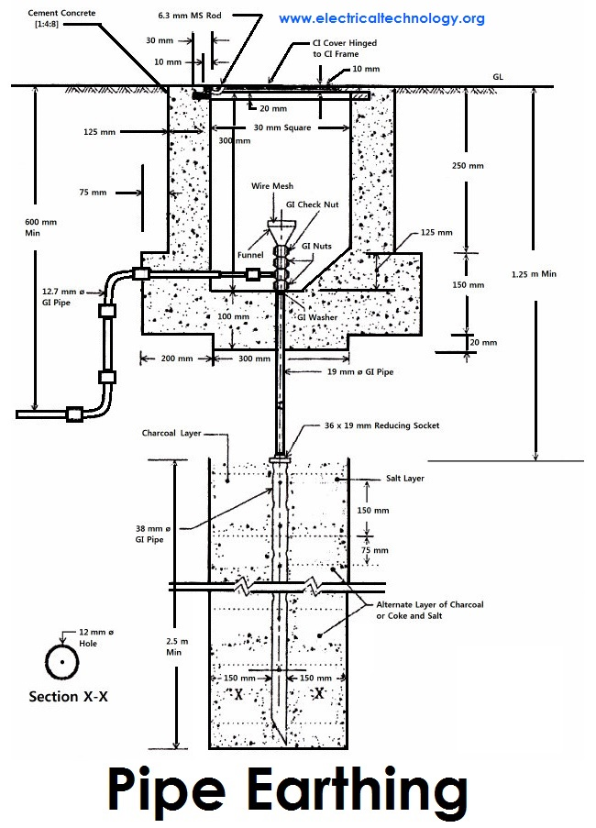

#### ****Rod Earthing****

 it is the same method as pipe earthing. A copper rod of 12.5mm (1/2 inch) diameter or 16mm (0.6in) diameter of galvanized steel or hollow section 25mm (1inch) of GI pipe of length above 2.5m (8.2 ft) are buried upright in the earth manually or with the help of a pneumatic hammer. The length of embedded electrodes in the soil reduces earth resistance to a desired value.

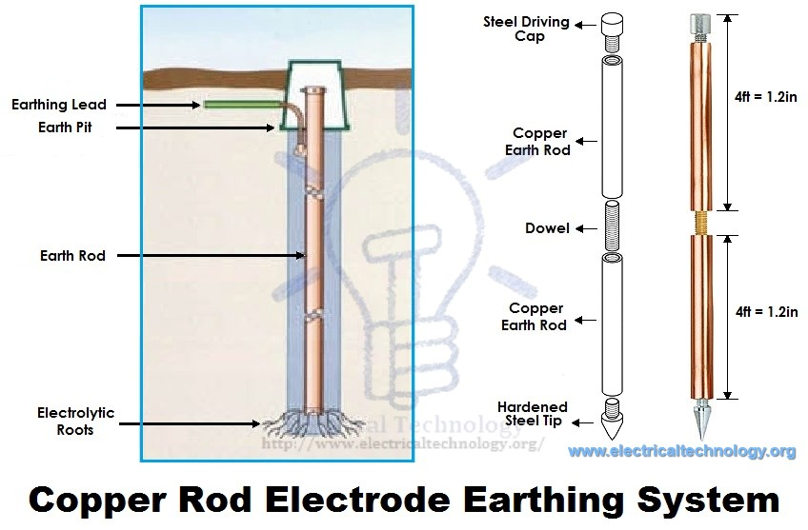

#### ****Strip or Wire Earthing:****

In this method of earthing, strip electrodes of cross-section not less than 25mm x 1.6mm (1in x 0.06in) is buried in a horizontal trenches of a minimum depth of 0.5m. If copper with a cross-section of 25mm x 4mm (1in x 0.15in) is used and a dimension of 3.0mm2 if it’s a galvanized iron or steel.

If at all round conductors are used, their cross-section area should not be too small, say less than 6.0mm2 if it’s a galvanized iron or steel. The length of the conductor buried in the ground would give a sufficient earth resistance and this length should not be less than 15m.

**MINIATURE CIRCUIT BAKERS:**

A miniature circuit breaker (MCB) automatically switches off electrical circuit during an abnormal condition of the network means in overload condition as well as faulty condition.

Nowadays we use an MCB in low voltage electrical network instead of a fuse. The fuse may not sense it but the miniature circuit breaker does it in a more reliable way. MCB is much more sensitive to overcurrent than fuse.

Handling an MCB is electrically safer than a fuse. Quick restoration of supply is possible in case of a fuse as because fuses must be re-wirable or replaced for restoring the supply. Restoration is easily possible by just switching it ON. Let’s look at the working of the miniature circuit breaker.

## The working principle of MCB

Whenever continuous overcurrent flows through MCB, the bimetallic strip is heated and deflects by bending. This deflection of bimetallic strip releases a mechanical latch. As this mechanical latch is attached with the operating mechanism, it causes to open the miniature circuit breaker contacts, and the MCB turns off thereby stopping the current to flow in the circuit. To restart the flow of current the MCB must be manually turned ON. This mechanism protects from the faults arising due to overcurrent or overload.

But during short circuit condition, the current rises suddenly, causing electromechanical displacement of plunger associated with a tripping coil or solenoid. The plunger strikes the trip lever causing immediate release of latch mechanism consequently open the circuit breaker contacts. This was a simple explanation of a miniature circuit breaker working principle.

An MCB is very simple, easy to use and is not generally repaired. It is just easier to replace. The trip unit is the main part, responsible for its proper working. There are two main types of trip mechanism. A bi-metal provides protection against overload current and an electromagnet provides protection against short-circuit current.

## MCB operation

If the circuit is overloaded for a long time, the bi-metallic strip becomes overheated and deformed. This deformation of Bi-metallic strip causes, displacement of latch point. The moving contact of the MCB is arranged by means of spring pressure, with this latch point, that a little displacement of latch causes, release of spring and makes the moving contact to move for opening the MCB.

The current coil or trip coil is placed so that during short circuit fault the magneto-motive force (mmf) of the coil causes its plunger to hit the same latch point and make the latch to be displaced. Again, when operating lever of the miniature circuit breaker is operated by hand, that means when MCB goes off position manually, the same latch point is displaced as a result moving contact separated from fixed contact in the same manner.

It may be due to deformation of a bi-metallic strip, or increased mmf of a trip coil or maybe a manual operation, the same latch point is displaced and same deformed spring is released, which ultimately responsible for movement of the moving contact. When the moving contact separated from fixed contact, there may be a high chance of arc. This arc then goes up through the arc runner and enters arc splitters and is finally quenched. When we switch it on, we reset the displaced operating latch to its previous on position and the MCB is ready for another switch off or trip operation.

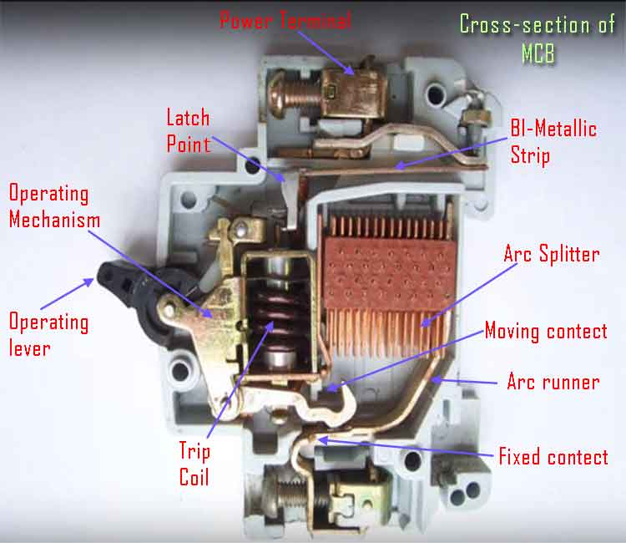

# Molded Case Circuit Breaker (MCCB) Working Principle:

A molded-case circuit breaker (MCCB) is a circuit breaker that uses a molded case to house and supports its current-carrying components as well as to be a part of the insulation system. The working principle of MCCB is discussed in detail in this article.

The most common type of MCCB is the thermal-magnetic general-purpose circuit breaker. See Figure 1. MCCBs often have a thermal overcurrent trip element to provide protection against overloads, such as what is caused when a coupling is misaligned on an electric motor or an electrical device draws too much current.

An instantaneous overcurrent element is also provided to protect against short circuits, such as what is caused when two wires touch or when insulation fails. MCCBs have the following primary components:

* frame or case
* contact assemblies
* Arc chutes
* OCPDs
* an operating mechanism
* Terminal connections

An insulated-case circuit breaker (ICCB) is a circuit breaker that is similar in construction to an MCCB but typically uses an electronic or digital OCPD and has much higher interrupting ratings.

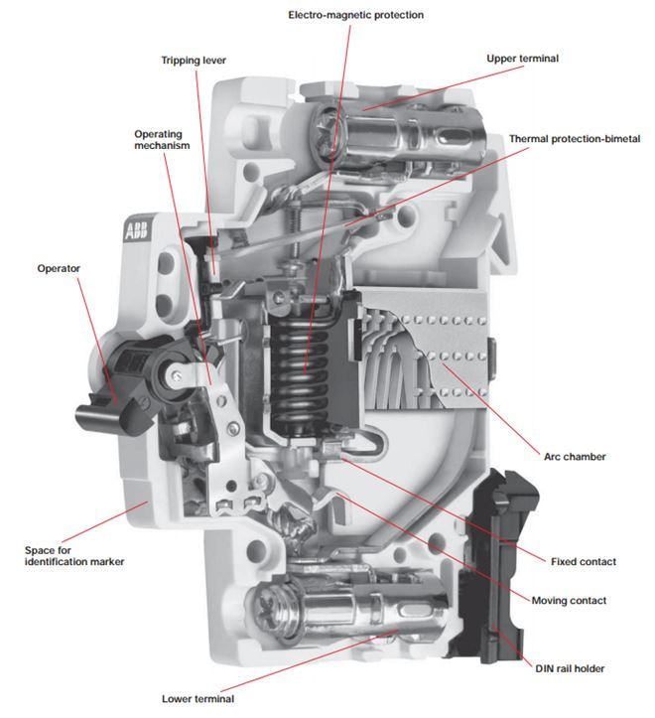

# Working Principle of Earth Leakage Circuit Breaker ELCB

## Earth Leakage Circuit Breaker or ELCB

If any [current](https://www.electrical4u.com/electric-current-and-theory-of-electricity/#what-is-electric-current) leaks from any electrical installation, there must-be any insulation failure in the [electrical circuit](https://www.electrical4u.com/electric-circuit-or-electrical-network/), it must be properly detected and prevented otherwise there may be a high chance of electrical shock if-anyone touches the installation. An **earth leakage circuit breaker** does it efficiently. Means it detects the earth leakage current and makes the power supply off by opening the associated [circuit breaker](https://www.electrical4u.com/electrical-circuit-breaker-operation-and-types-of-circuit-breaker/). There are two types of **earth leakage**

**There are two types of ELCBs:**

1. Voltage Earth Leakage [**Circuit Breaker**](https://electrical-engineering-portal.com/download-center/books-and-guides/siemens-basics-of-energy/basics-of-circuit-breakers) (voltage-ELCB)
2. Current Earth Leakage Current Earth Leakage Circuit Breaker (Current-ELCB).

## Voltage Base ELCB:

* Voltage-ELCB is a voltage operated circuit breaker. The device will function when the Current passes through the ELCB. Voltage-ELCB contains relay Coil which it being connected to the metallic load body at one end and it is connected to ground wire at the other end.  
  .
* If the voltage of the Equipment body is rise (by touching phase to metal part or failure of [**insulation of equipment**](https://electrical-engineering-portal.com/insulating-materials-in-electrical-equipment)) which could cause the difference between earth and load body voltage, the danger of electric shock will occur. This voltage difference will produce an electric current from the load metallic body passes the relay loop and to earth. When voltage on the equipment metallic body rose to the danger level which exceed to 50Volt, the flowing current through relay loop could move the relay contact by disconnecting the supply current to avoid from any danger electric shock.  
  .
* The ELCB detects fault currents from live to the earth (ground) wire within the installation it protects. If sufficient voltage appears across the ELCB’s sense coil, it will switch off the power, and remain off until manually reset. A voltage-sensing ELCB does not sense fault currents from live to any other earthed body.

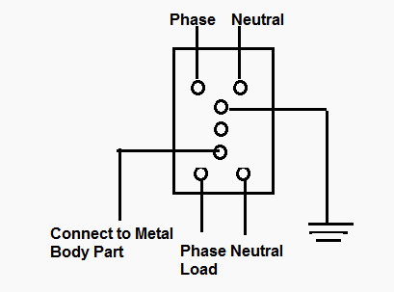

* These ELCBs monitored the voltage on the earth wire, and disconnected the supply if the earth wire voltage was over 50 volts.

.

* These devices are no longer used due to its drawbacks like if the fault is between live and a circuit earth, they will disconnect the supply. However, if the fault is between live and some other earth (such as a person or a metal water pipe), they will NOT disconnect, as the voltage on the circuit earth will not change. Even if the fault is between live and a circuit earth, parallel earth paths created via gas or water pipes can result in the ELCB being bypassed. Most of the fault current will flow via the gas or water pipes, since a single earth stake will inevitably have a much higher impedance than hundreds of meters of metal service pipes buried in the ground.
* **The way to identify an ELCB is by looking for green or green and yellow earth wires entering the device.** They rely on voltage returning to the trip via the earth wire during a fault and afford only limited protection to the installation and no personal protection at all. You should use plug in 30mA RCD’s for any appliances and extension leads that may be used outside as a minimum.

## Current-operated ELCB (RCB)

* Current-operated ELCBs are generally known as Residual-current devices (RCD). These also protect against earth leakage. Both circuit conductors (supply and return) are run through a sensing coil; any imbalance of the currents means the magnetic field does not perfectly cancel. The device detects the imbalance and trips the contact.  
  .
* When the term ELCB is used it usually means a voltage-operated device. Similar devices that are current operated are called residual-current devices. However, some companies use the term ELCB to distinguish high sensitivity current operated 3 phase devices that trip in the milliamp range from traditional 3 phase ground fault devices that operate at much higher currents.
* 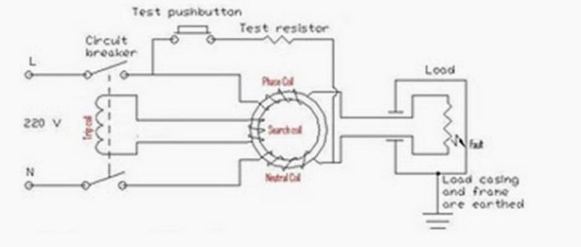 The supply coil, the neutral coil and the search coil all wound on a common transformer core.  
  .
* On a healthy circuit the same current passes through the phase coil, the load and return back through the neutral coil. Both the phase and the neutral coils are wound in such a way that they will produce an opposing magnetic flux. With the same current passing through both coils, their magnetic effect will cancel out under a healthy circuit condition.  
  .
* In a situation when there is fault or a leakage to earth in the load circuit, or anywhere between the load circuit and the output connection of the RCB circuit, the current returning through the neutral coil has been reduced. Then the magnetic flux inside the transformer core is not balanced anymore. The total sum of the opposing magnetic flux is no longer zero. This net remaining flux is what we call a residual flux.  
  .
* The periodically changing residual flux inside the transformer core crosses path with the winding of the search coil. This action produces an electromotive force (e.m.f.) across the search coil. An electromotive force is actually an alternating voltage. The induced voltage across the search coil produces a current inside the wiring of the trip circuit. It is this current that operates the trip coil of the circuit breaker. Since the trip current is driven by the residual magnetic flux (the resulting flux, the net effect between both fluxes) between the phase and the neutral coils**, it is called the residual current devise**. **.**
* With a circuit breaker incorporated as part of the circuit, the assembled system is called residual current circuit breaker (RCCB) or residual current devise (RCD). The incoming current has to pass through the circuit breaker first before going to the phase coil. The return neutral path passes through the second circuit breaker pole. During tripping when a fault is detected, both the phase and neutral connection is isolated.  
  .
  + RCD sensitivity is expressed as the rated residual operating current, noted **IΔn**. Preferred values have been defined by the IEC, thus making it possible to divide RCDs into three groups according to their IΔn value.
  + High sensitivity (**HS**): 6- 10- 30 mA (for direct-contact / life injury protection)
  + Standard IEC 60755 (General requirements for residual current operated protective devices) defines three types of RCD depending on the characteristics of the fault current.
  + Type **AC**: RCD for which tripping is ensured for residual sinusoidal alternating currents

**POWER FACTOR AND ITS IMPROVE METHODS:**

In general power is the capacity to do work. In electrical domain, [electrical power](https://www.electrical4u.com/electric-power-single-and-three-phase/) is the amount of electrical energy that can be transferred to some other form (heat, light etc) per unit time. Mathematically it is the product of [voltage drop](https://www.electrical4u.com/voltage-drop-calculation/) across the element and [current](https://www.electrical4u.com/electric-current-and-theory-of-electricity/) flowing through it. Considering first the [DC circuit](https://www.electrical4u.com/electrical-dc-series-and-parallel-circuit/)s, having only DC [voltage sources](https://www.electrical4u.com/ideal-dependent-independent-voltage-current-source/), the [inductors](https://www.electrical4u.com/what-is-inductor-and-inductance-theory-of-inductor/) and [capacitors](https://www.electrical4u.com/what-is-capacitor/) behave as short circuit and open circuit respectively in steady state.

Hence the entire circuit behaves as resistive circuit and the entire electrical power is dissipated in the form of heat. Here the [voltage](https://www.electrical4u.com/voltage-or-electric-potential-difference/) and current are in same phase and the total electrical power is given by:

https://www.electrical4u.com/images/2017/may/1495189443.PNG

Now coming to AC circuit, here both inductor and capacitor offer a certain amount of impedance given by:

https://www.electrical4u.com/electrical/power-system-equations/transmission-equation/electrical-power-factor-1.gif

The [inductor](https://www.electrical4u.com/what-is-inductor-and-inductance-theory-of-inductor/) stores electrical energy in the form of magnetic energy and capacitor stores electrical energy in the form of electrostatic energy. Neither of them dissipates it. Further, there is a phase shift between voltage and current.

Hence when we consider the entire circuit consisting of a [resistor](https://www.electrical4u.com/types-of-resistor/), inductor, and capacitor, there exists some phase difference between the source voltage and current.

The cosine of this phase difference is called **electrical power factor**. This factor (-1 < cosφ < 1 ) represents the fraction of the total power that is used to do the useful work. The other fraction of electrical power is stored in the form of magnetic energy or electrostatic energy in the inductor and [capacitor](https://www.electrical4u.com/what-is-capacitor/) respectively.

The total power in this case is:

https://www.electrical4u.com/images/2017/may/1495189589.PNG

This is called [apparent power](https://www.electrical4u.com/electric-power-single-and-three-phase/) and its unit is VA (Volt Amp) and denoted by ‘S’. A fraction of this total electrical power which does our useful work is called active power. We denote it as ‘P’.

P = Active power = Total electrical power.cosφ and its unit is watt.

## Power Factor Improvement

The term power factor comes into the picture in AC circuits only. Mathematically it is the cosine of the phase difference between the source voltage and current. It refers to the fraction of total power (apparent power) which is utilized to do the useful work called active power.

https://www.electrical4u.com/electrical/power-system-equations/transmission-equation/electrical-power-factor-2.gif

Need for Power Factor Improvement

* Real power is given by P = VIcosφ. The electrical current is inversely proportional to cosφ for transferring a given amount of power at a certain [voltage](https://www.electrical4u.com/voltage-or-electric-potential-difference/). Hence higher the pf lower will be the current flowing. A small current flow requires a less cross-sectional area of conductors, and thus it saves conductors and money.
* From the above relation, we see having poor power factor increases the current flowing in a conductor and thus copper loss increases. A large [voltage drop](https://www.electrical4u.com/voltage-drop-calculation/) occurs in the [alternator](https://www.electrical4u.com/alternator-or-synchronous-generator/), [electrical transformer](https://www.electrical4u.com/what-is-transformer-definition-working-principle-of-transformer/) and transmission and distribution lines – which gives very poor voltage regulation.
* The KVA rating of machines is also reduced by having higher power factor, as per the formula:

https://www.electrical4u.com/wp-content/uploads/electrical-power-factor-formula.png

Hence, the size and cost of the machine is also reduced.

This is why electrical power factor should be maintained close to unity – it is significantly cheaper.

### Methods of Power Factor Improvement

There are three main ways to improve power factor:

* Capacitor Banks
* Synchronous Condensers
* Phase Advancers

### Capacitor Banks

Improving power factor means reducing the phase difference between voltage and current. Since the majority of loads are of inductive nature, they require some amount of reactive power for them to function.

A [capacitor](https://www.electrical4u.com/what-is-capacitor/) or bank of capacitors installed parallel to the load provides this reactive power. They act as a source of local reactive power, and thus less reactive power flows through the line.

Capacitor banks reduce the phase difference between the [voltage](https://www.electrical4u.com/voltage-or-electric-potential-difference/) and current.

### Synchronous Condensers

Synchronous condensers are 3 phase synchronous motor with no load attached to its shaft.

The [synchronous motor](https://www.electrical4u.com/synchronous-motor-working-principle/) has the characteristics of operating under any power factor leading, lagging or unity depending upon the excitation. For inductive loads, a [synchronous condenser](https://www.electrical4u.com/synchronous-condenser/) is connected towards load side and is overexcited.

Synchronous condensers make it behave like a capacitor. It draws the lagging current from the supply or supplies the reactive power.

### Phase Advancers

This is an AC exciter mainly used to improve the PF of an [induction motor](https://www.electrical4u.com/induction-motor-types-of-induction-motor/).

They are mounted on the shaft of the motor and are connected to the rotor circuit of the motor. It improves the power factor by providing the exciting ampere turns to produce the required [flux](https://www.electrical4u.com/what-is-flux-types-of-flux/) at the given slip frequency.

Further, if ampere-turns increase, it can be made to operate at leading power factor.

## Power Factor Calculation

In **power factor calculation**, we measure the source voltage and current drawn using a [voltmeter](https://www.electrical4u.com/working-principle-of-voltmeter-and-types-of-voltmeter/) and [ammeter](https://www.electrical4u.com/ammeter/) respectively. A [wattmeter](https://www.electrical4u.com/electrodynamometer-type-wattmeter/) is used to get the active power.

Now, we know P = VIcosφ watt

https://www.electrical4u.com/electrical/power-system-equations/transmission-equation/electrical-power-factor-4.gif

Hence, we can get the electrical power factor.

Now we can calculate the reactive power Q = VIsinφ VAR

This reactive power can now be supplied from the capacitor installed in parallel with the load in local. The reactive power of a [capacitor](https://www.electrical4u.com/what-is-capacitor/) can be calculated using the following formula:

https://www.electrical4u.com/electrical/power-system-equations/transmission-equation/electrical-power-factor-5.gif

Top of Form

Enter your email below to receive FREE informative articles on Electric

**Calculation of Electrical Energy :**

**Energy :**

The formula that links energy and power is: Energy = Power x Time. The unit of energy is the joule, the unit of power is the watt, and the unit of time is the second.

**The Kilowatt Hour (kWh) :**

Because the joule is so small, electrical energy supplied to consumers is bought by the UNIT. The UNIT is the kilowatt hour (kWh). One kilowatt hour is the amount of energy that would be converted by a one thousand watt appliance when used for one hour.

Example :A consumer uses a 6 kW immersion heater, a 4 kW electric stove and three 100 watt lamps for 10 hours. How many units (kWh) of electrical energy have been converted.

Total power in kilowatts = 6 + 4 + 300/1000. = 10.3kW.

Energy in kilowatt hours = Power in watts x time in hours =10.3 x 10 = 103 kilowatt hours

Electrical supply authorities use the kWh as the unit for measuring electrical energy to householders.

**BATTERIES:**

Battery or cells are referred to as the parallel combination of [electrochemical cells](https://byjus.com/chemistry/electrochemical-cell/). The major difference between a primary cell and the secondary cell is that primary cells are the ones that cannot be charged but secondary cells are the ones that are rechargeable.

## Primary cell:

Primary cells have high density and get discharged slowly. Since there is no fluid inside these cells they are also known as dry cells. The internal resistance is high and the [chemical reaction](https://byjus.com/chemistry/chemical-reactions/) is irreversible. Its initial cost is cheap and also primary cells are easy to use.

## Secondary cell:

Secondary cells have low energy density and are made of molten salts and wet cells. The internal resistance is low and the chemical reaction is reversible. Its initial cost is high and is a little complicated to use when compared to the primary cell.

## Difference Between Primary Cell and Secondary Cell:

Primary cells are the ones which cannot be recharged and has to be discarded after the expiration of the lifetime whereas, secondary cells need to be recharged when the charge gets over. Both the [types of battery](https://byjus.com/chemistry/battery-types/) are used extensively in various appliances and these cells differ in size and material used in them.

|  |  |
| --- | --- |
| Difference Between Primary Cell and Secondary Cell | |
| **Primary Cell** | **Secondary Cell** |
| Have high energy density and slow in discharge and easy to use | They are smaller energy density |
| There are no fluids in the cells hence it is also called as dry cells | There are made up of wet cells (flooded and liquid cells) and molten salt (liquid cells with different composition) |
| It has high internal resistance | It has low internal resistance |
| It has an irreversible chemical reaction | It has a reversible chemical reaction |
| Its design is smaller and lighter | Its design is more complex and heavier |
| Its initial cost is cheap | Its initial cost is high |

**The following battery characteristics must be taken into consideration when selecting a battery:**

* Type.
* Voltage.
* Discharge curve.
* Capacity.
* Energy density.
* Specific energy density.
* Power density.
* Temperature dependence.

Bottom of Form